
Department of Biomedical Engineering

BME 105L – Applications of ITC
Lab Manual
Semester: Spring 2026

Name: __________________________________
Student ID.: _____________________________
Batch: __________________________________

Submitted to:
Miss. Edina David
Date: ___________ Lab 3 Student ID.: __________
Learning Objectives

In this lab you will learn:
- How to create professional biomedical reports in Microsoft Word
- How to format medical documents properly
- How to create tables for patient or equipment data
- How to insert headers, footers, and page numbers
- How to insert images and captions
- How to generate automatic Table of Contents
- How to apply referencing and professional document structure
Object: Report Preparation Using Microsoft Word

1. Introduction
Microsoft Word is a word processing software used to create professional documents such as:
- Patient reports
- Biomedical equipment documentation
- Research papers
- Lab manuals
- Hospital policies
- Technical project reports
In biomedical engineering, proper documentation is extremely important for:
- Regulatory compliance
- Clinical reporting
- Research publication
- Equipment maintenance documentation
A poorly formatted report can lead to miscommunication and professional errors.

2. Microsoft Word in Biomedical Engineering

2.1 Clinical Report Writing
Biomedical engineers often prepare:
- Equipment inspection reports
- Calibration certificates
- Incident analysis reports
- Patient device performance reports
Word allows structured documentation using:
- Headings
- Tables
- Images
- Page numbers
- Professional formatting

2.2 Importance of Formatting
Proper formatting ensures:
- Clear readability
- Professional appearance
- Standardized documentation
- Easy navigation
Hospitals and research institutions require standardized report formats.

Lab Task 01

OPENING MICROSOFT WORD & SAVING FILE

Step 0.1: Open Word
- Click Start Menu
- Type Word
- Click Microsoft Word
- Click Blank Document

Step 0.2: Save File Properly
- Click File
- Click Save As
- Choose Desktop
- File name:
Biomedical_Technical_Report.docx
- Click Save
OUTPUT of Lab Task 01


Lab Task 02

CREATING A PROFESSIONAL BIOMEDICAL REPORT

Step 1: Create Title Page
Type the following (center aligned):
BIOMEDICAL EQUIPMENT INSPECTION REPORT
Hospital Name: ABC Hospital
Department: Biomedical Engineering
Prepared By: Your Name
Date: (Insert today’s date)

Formatting:
- Select title
- Font size: 18
- Bold
- Font: Times New Roman
- Insert Page Break (Ctrl + Enter)

Step 2: Create Headings Structure
Type the following:
- Introduction
- Equipment Details
- Inspection Procedure
- Observations
- Conclusion
Select each heading:
Home → Styles → Apply Heading 1

Step 3: Write Sample Content

Under Introduction:
Write 5–6 lines explaining importance of equipment inspection in hospitals.

Step 4: Insert Equipment Table
Go to:
Insert → Table → 5 Columns × 6 Rows
Enter:
Equipment Name | Equipment ID | Department | Last Calibration | Status
ECG Machine | EQ-001 | Cardiology | 15-Nov-2025 | Valid
Ventilator | EQ-002 | ICU | 10-Oct-2025 | Due
Defibrillator | EQ-003 | Emergency | 9-Jan-2025 | Overdue
Patient Monitor | EQ-004 | ICU | 20-Dec-2025 | Valid
Infusion Pump | EQ-005 | ICU | 8-Dec-2025 | Valid
Make headings bold.

Step 5: Apply Table Formatting
- Select table
- Go to Table Design
- Choose a professional style
- Center align table
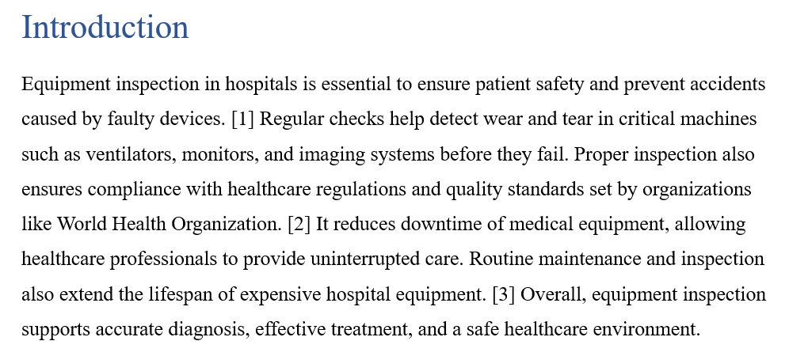
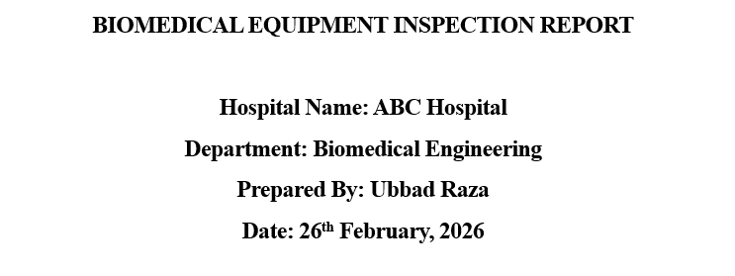
OUTPUT of Lab Task 02
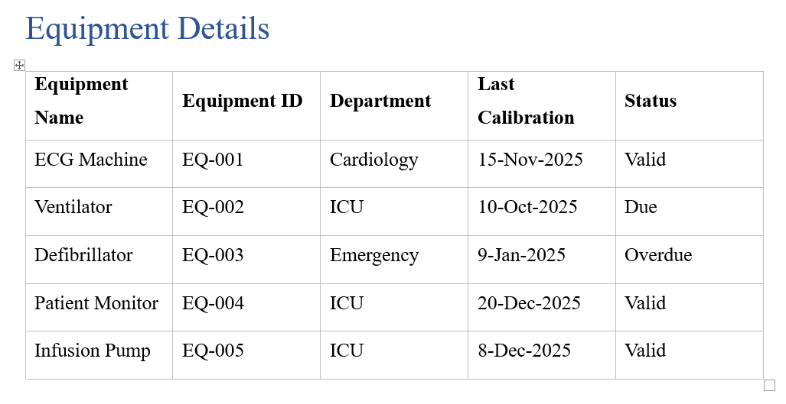


Lab Task 03

INSERTING IMAGES AND CAPTIONS

Step 1: Insert Biomedical Equipment Image
- Go to Insert
- Click Pictures
- Choose any medical equipment image
Resize properly.

Step 2: Add Caption
Right click image → Insert Caption
Type:
Figure 1: ECG Machine Used in Cardiology Department
This is important in research and thesis writing.
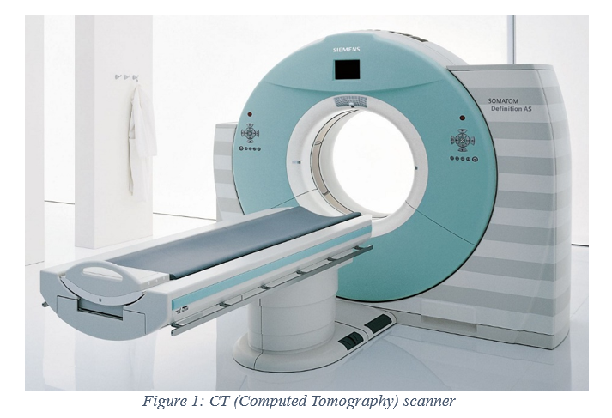
OUTPUT of Lab Task 03

Lab Task 04

HEADER, FOOTER & PAGE NUMBERS

Step 1: Insert Header
Insert → Header
Type:
Biomedical Engineering Department – SHU

Step 2: Insert Page Numbers
Insert → Page Number → Bottom of Page → Plain Number
OUTPUT of Lab Task 04

Lab Task 05

AUTOMATIC TABLE OF CONTENTS

Step 1:
Go to top of document
Type:
Table of Contents
Press Enter
Go to:
References → Table of Contents → Automatic Table
Word will automatically generate Table of Contents based on Heading styles.
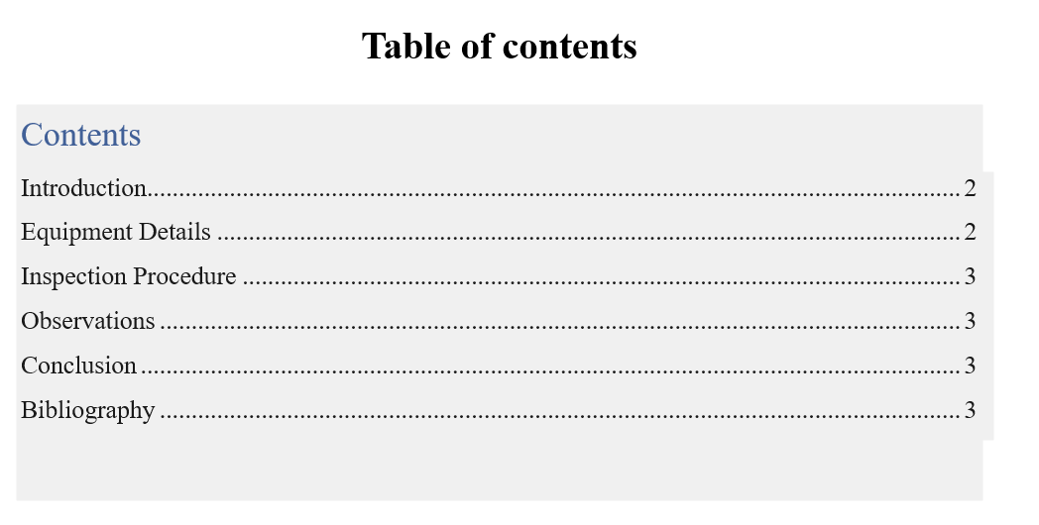
OUTPUT of Lab Task 05

Lab Task 06

PAGE FORMATTING

Step 1: Change Margins
Layout → Margins → Normal

Step 2: Line Spacing
Select entire document → Line spacing → 1.5

Step 3: Justify Text
Select paragraphs → Click Justify

Lab Task 07:

ADDING REFERENCES USING MICROSOFT WORD ONLY

Step 1: Select Citation Style in Word
- Open your Word document.
- Click the References tab.
- Locate the Style dropdown.
- Select:
  - IEEE
OR
  - APA 7th Edition

Step 2: Insert a Citation
- Place cursor at the end of a sentence.
- Click:
References → Insert Citation → Add New Source
A new window will appear.
Step 3: Enter Source Details
- Choose source type:
  - Journal Article
  - Website
  - Book
- Fill required fields:
  - Author
  - Title
  - Year
  - Publisher / Journal Name
- Click OK.
Word will automatically insert the in-text citation.
Example (IEEE):
[1]

Step 4: Add Multiple Citations
Repeat the same process to add at least:
• 3 sources
Word will automatically number them in correct order (for IEEE).
Step 5: Generate Bibliography Automatically
- Go to the last page of your document.
- Type:
References
- Press Enter.
- Click:
References → Bibliography
- Select:
“Insert Bibliography”
Word will automatically generate the reference list.
Step 6: Update References
If you add a new citation:
- Click inside the bibliography.
- Click Update Citations and Bibliography.
Word will refresh automatically.
OUTPUT of Lab Task 07
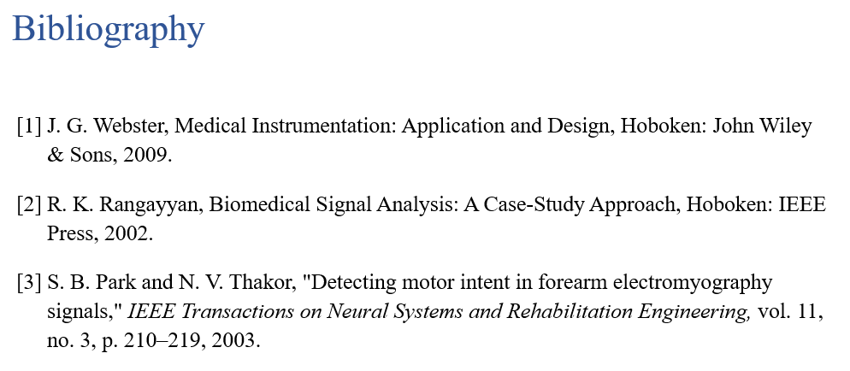

Conclusion
In this lab, we learned how to create a professional biomedical report using Microsoft Word. We practiced formatting documents, inserting tables and images, adding headers and page numbers, and generating an automatic Table of Contents. We also learned how to insert and manage references properly. These skills are very important for preparing clear, organized, and professional reports in biomedical engineering.

Date: ___________ Student ID.: __________
Object: To analyze and enhance the report created during Lab 3 and apply advanced Microsoft Word tools in professional biomedical documentation scenarios. Also, learning the usage of an online citation generator to automatically generate in text citations and bibliography for academic and professional work.

Post Lab Task 1

Clinical Documentation Enhancement
Create a new report titled:
“Medical Device Failure Analysis Report”
Include:
- Title page
- At least 4 headings
- One table
- One image with caption
- Header and footer
- Page numbers
- Automatic Table of Contents

Post Lab Task 2

Research Paper Formatting
Format your document according to:
- Font: Times New Roman
- Size: 12
- Line spacing: 1.5
- Justified text
Insert:
- 3 references manually
- Page number format: Roman numerals for first page

Post Lab Task 3

Advanced Features
- Use Find & Replace to replace word “Equipment” with “Medical Device”
- Insert a page border
- Insert a SmartArt diagram showing Inspection Workflow
- Add a watermark: “Confidential”

Post Lab Task 04:

Referencing using Mibib (In-Text citation & Bibliography)
Add at least:
• 2 journal articles
• 1 website source
Generate:
• In-text citations
• Proper bibliography list

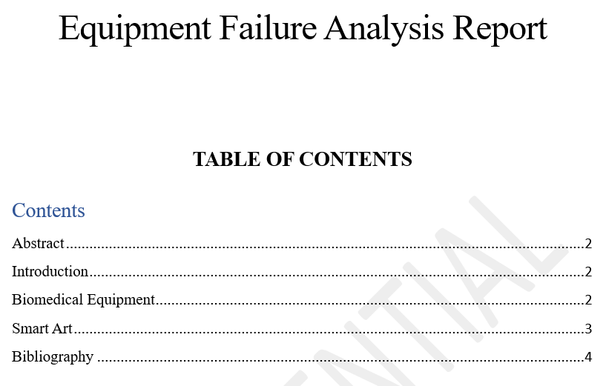
OUTPUT of Post Lab Tasks

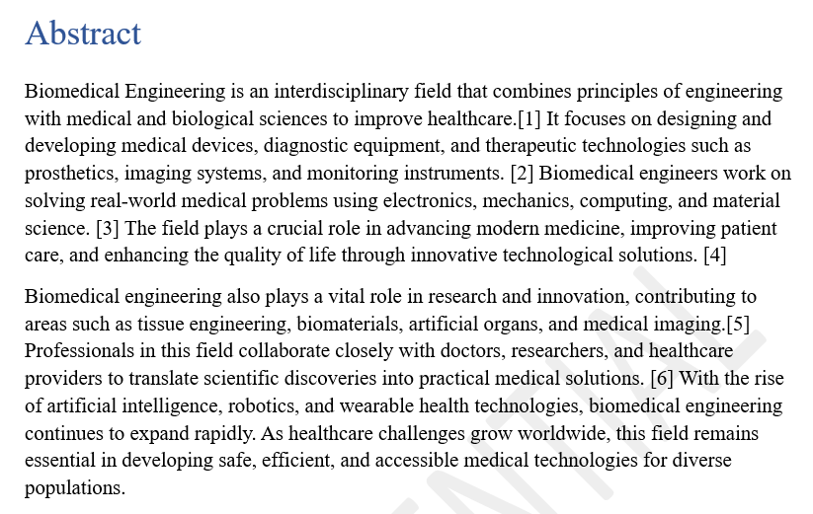

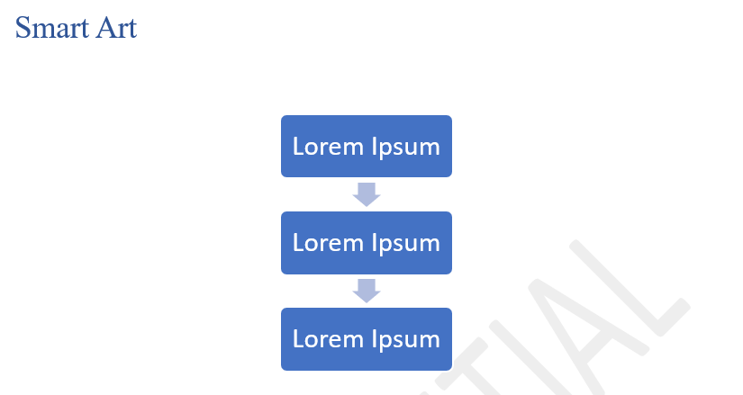
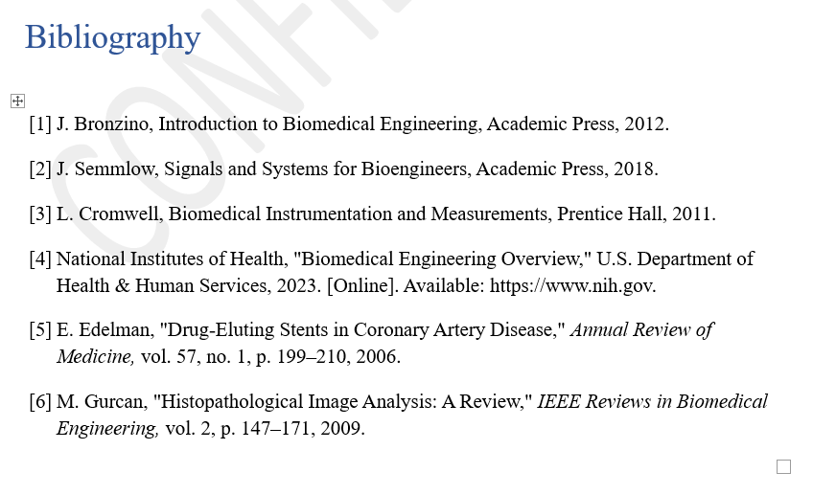
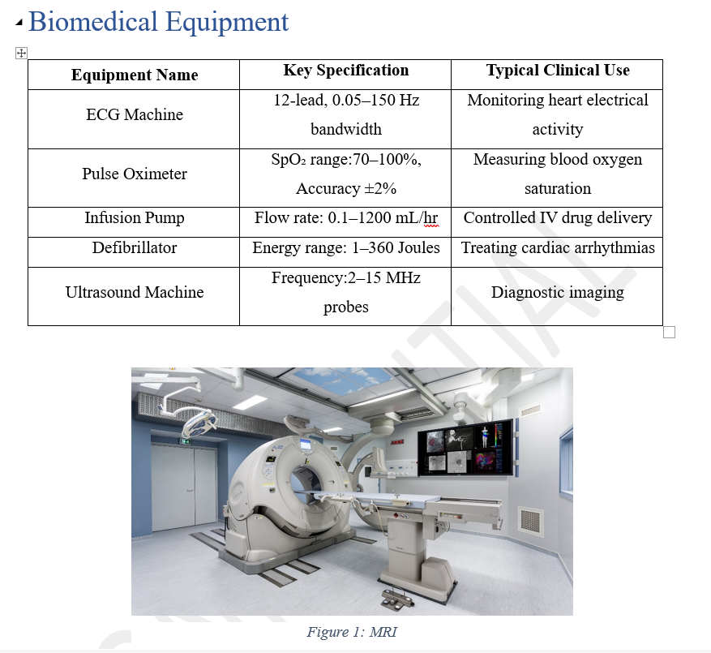

Critical Thinking Questions
- Why is professional documentation important in biomedical engineering?
Professional documentation is important in biomedical engineering because it keeps accurate records of how medical devices are designed, tested, and maintained. It ensures safety, helps meet legal and regulatory requirements, and makes it easier for engineers and doctors to understand and use the equipment properly.
- What problems can arise from poorly formatted hospital reports?
Poorly formatted hospital reports can cause confusion, misinterpretation, and medical errors because important information may be unclear or missing. This can delay treatment and put patient safety at risk.
- Why is automatic Table of Contents useful in long research reports?
An automatic Table of Contents helps readers quickly find different sections in a long research report. It also updates page numbers automatically, saving time and reducing mistakes when the document is edited.
- How can Word improve communication between biomedical engineers and doctors?
Microsoft Word helps biomedical engineers and doctors share clear reports, device manuals, and research findings in a professional format. It improves communication by organizing information properly and reducing misunderstandings.

